# GOVERNMENT POLYTECHNIC COLLEGE MATTANNUR-670702

### (Department of Technical Education, Kerala)



**SEMINAR REPORT ON**

**ULTRASONIC MOTOR**

**SUBMITTED BY RITHURAJ T V**

**(Reg.No:19041675)**

**DEPARTMENT OF ELECTRONICS ENGINEERING**

**2021-22**

**GOVERNMENT POLYTECHNIC COLLEGE MATTANNUR-670702**

**(Department of Technical Education, Kerala)**



**CERTIFICATE**

*Certified that seminar work entitled* “***ULTRASONIC MOTOR*”***is a bonafide work carried out by* **“*RITHURAJ T V* ”** *in partial fulfilment for the award of Diploma in Electronics Engineering from Government Polytechnic College Mattannur during the academic year* 2021-2022.

### Seminar Co-ordinator Head of Section

**Internal Examiner External Examiner**

**DECLARATION**

I hereby declare that the report of *the* ***ULTRASONIC MOTOR*** work entitled which is being submitted to the Govt. Polytechnic College Mattannur, in partial fulfilment of the requirement for the award **of *Diploma in Electronics Engineering*** *i*s a confide report of the work carried out by me. The material in this report has not been submitted to any institute for the award of any degree.

Place:Mattannur **RITHURAJ T V**

Date:

### ACKNOWLEDGEMENT

I would like to take this opportunity to extend my sincere thanks to people who helped me to make this seminar possible. This seminar will be incomplete without mentioning all the people who helped me to make itreal.

Firstly, I would like to thank GOD, almighty, our supreme guide, for bestowing his blessings upon me in my entire endeavor.

I would like to express my deepest gratitude **Mr. M C PRAKASHAN** (Principal GPTC, Mattannur), **Mr. GEORGE KUTTY P P(**Head of Department of Electronics Engg.), for the help rendered by him to prepare and present this Seminar in proper way. Moreover I am very much indebted to **Mr. SREEJITH A** (Lecturer, Electronics Engg, seminar co-ordinator), for their advice.

I am also indebted to all my friends and classmates who have given valuable suggestion and encouragement.

**RITHURAJ T V**

**ABSTRACT**

Endoscopy is part of the medical terminology which refers to looking inside the body for medical reasons using an endoscope, an instrument used to examine the interior of a hollow organ or cavity of the body. Endoscopes usually use a rigid or flexible fiber optic tube with a video camera at the end which is inserted directly into the organ. For examining the inside lining of the digestive tract and for early imaging of the intestine to prevent disease, gastrointestinal endoscopy (GI) is used. The insertion of the long narrow endoscopic tube may produce discomfort to the patient and there may also be the problem of the endoscopic tube facing difficulty in imaging areas that are hard to reach.

As it is rightly necessary said, "Necessity is the mother of invention", the discomfort caused by the patient during long hours of examination and the failure of the endoscope to capture images of the deeper regions of the intestine made way for the invention of a tubeless device carrying a miniaturized video camera, is equipped with a tracking device and is the size of a pill, thereby making it easy to swallow. While this imaging pill is moved through the gastrointestinal tract by the natural action of the intestinal muscles, it transmits images to a recorder carried on a belt worn by the patient. About the size of a large vitamin, the capsule is made of a specially sealed biocompatible material that is resistant to stomach acid and powerful digestive enzymes. Patients swallow the capsule in the morning and wear the recording device for 8 hours.

"Camera Pill" or Capsule endoscopy, is a new diagnostic tool that permits a direct visual examination of the small intestine, an area of the body not previously accessible using upper endoscopy from above or colonoscopy from below. The pill, known as the M2A Capsule Endoscopy, is about the size of a multivitamin and is swallowed with a sip of water. The pill is made of specially sealed biocompatible material that is resistant to stomach acid and powerful digestive enzymes and thus every care is taken such that the caps will not rupture or burst. Its non-invasive diagnostic alternative that is relatively quick, easy, office based test that will encourage people to see their doctors to get checked for diseases"

TABLE OF CONTENTS

**CHAPTERNO TOPICS PAGENO**

Chapter1 INTRODUCTION……………………………………...8

Chapter2 GENERAL OVERVIEW……………………………….9

Chapter2.1 PROSTHESIS………………………………………......9

Chapter2.2 MECHATRONICS……………………..………………9

Chapter2.3 BIOMECHATRONICS…………….....……………..…9

Chapter3 WORKING………………………..………………..….10

Chapter3.1 BIOSENSORS………………………………….….…..10

Chapter3.2 MECHANICAL SENSORS…………………………...10

Chapter3.3 KINEMATICS ARCHITECTURES…………………..10

Chapter3.4 CONTROLLER…………………………………….….11

Chapter3.5 ACTUATOR………………………….……………….11

Chapter4 NATURAL HAND AND BIOMECHATRONIC HAND..………….……………………………….……12

Chapter4.1 NATURAL HAND………………….…..…………….12

Chapter4.2 BIOMECHATRONIC HAND………….………….….12

Chapter5 DESGIN AND HAND PROTOTYPE….…………..…14

Chapter5.1 ACTUATOR SYSTEM ARCHITECTURE……….….14

Chapter6 POSTION AND FORCE SENSORS…..……………....16

Chapter6.1 SENSORS……………………………………………...16

Chapter6.2 USE OF SENSORS IN ROBOTICS……………….….16

Chapter6.3 POSITION SENSORS…………………….……….….16

Chapter7 FINGERED TIP FORCE ANALYSIS………………..18

Chapter8 ADAVANTAGES AND DISADVANTAGES……….20

Chapter9 FURTURISTIC ASPECTS…………………………....21

Chapter10 CONCLUSION………………………………………..23

Chapter11 REFERENCE………………………………………….24

|  |  |  |
| --- | --- | --- |
| **FIGURE NO** | **LIST OF FIGURES**  **NAME** | **PAGE NO** |
| Fig 2.1 | A SOLDIER WITH PROSTHETIC ARMS PLAY FOOTBALL....................................... | 9 |
| Fig 4.1  Fig 4.2 | NATURAL HAND……………….......……..  MECHATRONIC HAND……………………. | 12  13 |
| Fig 5.1  Fig 5.2 | FINGER PROTO TYPE……………………..  HIGH PRECISION LINEAR ACTUATOR… | 14  14 |
| Fig 7.1  Fig 7.2  Fig 9.1  Fig 9.2 | POSITIONING OF FINGERPRINT…………  EXPERIMENTAL RESULT…………………  PORTABLE ARM MOVEMNET  TRAINING………………………………….  SENSORY MOTOR PERFORMANCE……. | 18  19  21  22 |

**CHAPTER 1**

**INTRODUCTION**

The pill (developed at university of Washington) consists of 70ptical fibers,one for illumination and the rest six for collecting light. once swallowed, electric current flows through the pill that causes the encased fibers to bounce back and forth such that its electronic eye would be able to scan the GI tract. The tip will ilummate red, green and blue laser light helping in visuallty, all this processing together combined will give us two-dimensional picture helping in diagnosis.The images can be retrieved from the recording device worn around patient's waist as a belt.

All this is about the technical side, but how about the patient compliance??? at the end of the day,'WE' are all here to make patient more comfoftable..Yup, the patient is comfoftable and convenient to swallow this large vitamin sized pill that can be taken with a mouthful of water.

"Its non-mvasive diagnostic alternative that is relatively quick, easy, office based test that will encourage people to see their doctors to get checked for diseæ;es" said by Dr. Michael Brown, the gastroenterologist.

The advancement of our technology today has lead to its effective use and Application to the medical field. One effective and purposeful application of the Advancement of technology is the process of endoscopy, which is used to diagnose and examine the conditions of the gastrointestinal tract of the patents. It has been reported that this process is done by inserting an 8mm tube through the mouth, with a camera at one end, and images are shown on nearby monitor, allowing the medics to carefully guide it down to the gullet or stomach

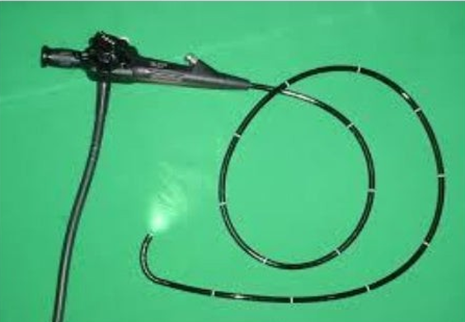

Fig 1.1 endoscopy

**CHAPTER 2**

**HISTORY**

Endoscopy means looking inside and typically refers to looking inside the body for the medical reasons using an endoscope Unlike most other medical imaging devices, endoscopes are insened directly into the organ. Endoscopy can also refer to using a borescope An endoscope is a flexible camera that travels into the body's cavities to directly investigate the digestive tract, colon or throat. These tools are long, flexible cords about 9 mm wide, about the width of a human fingernail. Because the cord is so wide patients must be sedated during the scan. The tiny camera is like swallowing a pill attached to a string. The camera's 1.4-mm,thick tether allows the doctor to move the camera around and pull it back up once the five- or 10-minute test is finished An endoscope can consist of

* A rigid or flexible tube

* A light delivery system to illuminate the organ or object under inspection, The light source is normally outside the body and the light is typically directed via an optical fiber system

* A lens system transmitting the image to the viewer from the fiber scope an additional channel to allow entry of medical instruments or manipulators

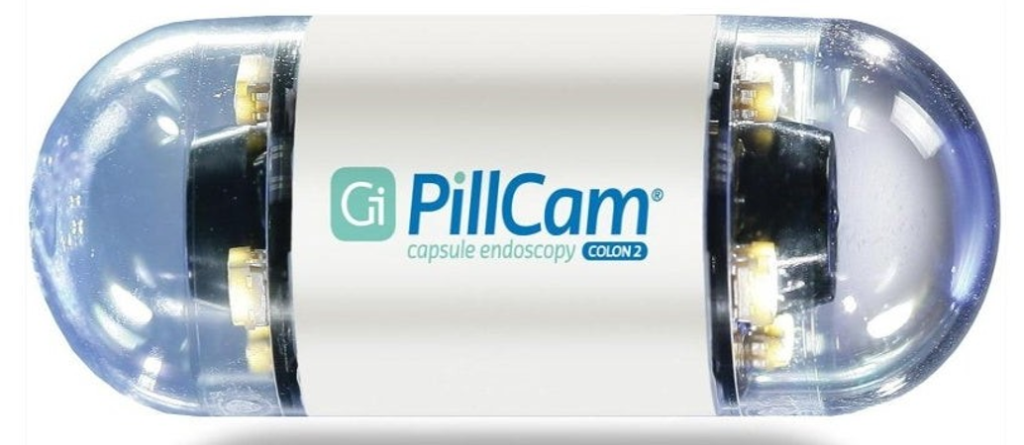

Fig 2.1 Pill camera

**CHAPTER 3**

**ARCHITECTURAL DESIGN**

Measuring 11x26 mm, the capsule is constructed with an isoplast outer envelope that is biocompatible and impervious to gastric fluids. Despite its diminutive profile, the envelope contains LEDs, a lens, a colour camera chip, two silver- oxide batteries, a transmitter, an antenna, and a magnetic switch. The camera chip is constructed in complementary-metal —oxide-semiconductor technology to require significantly less power than charge-coupled devices.

Other construction benefits includes the unit's dome shaped that cleans itself of body fluids and moves along to ensure optimal imaging to its obtained. For this application, small size and power efficiency are important.

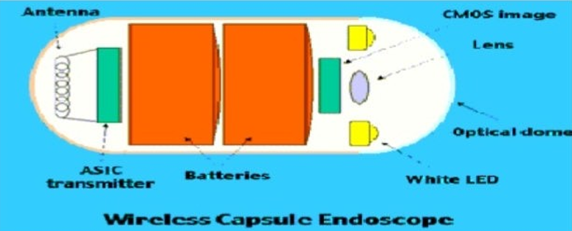

Fig 3.1 wireless capsule endoscopy

The silver oxide batteries in the capsule power the CMOS detector, as well as the LEDs and transmitter. The white- light LEDs are important because pathologists distinguish diseased tissue by colour The developers provided a novel optical design that uses a wide-angle over the imager rand manages to integrate both the LEDs and imager under one dome while hadliung stray light and reflections. Recent advances in ASIC design allowed the integration of a video transmitter of sufficient power output ,efficiencyj and band width of very small size into the capsule. Synchronous switching of the LEDs, the CMOS sensor, and ASI C transmitter minimizes the power consumptions. The system's computer work station is equipped with software for reviewing the camera data using a variety of diagnostic tools. This allows physicians choice of viewing the information as either streaming or single video images.

**CHAPTER 4**

**INTERNAL VIEW OF CAPSULE**

The figure shows the internal view of the pill camera. It has 8 parts:

1. Optical Dome.
2. Lens Holder.
3. Lens
4. Illuminating LEDs.
5. CMOS Image Sensor.
6. Battery.
7. ASIC Transmitter.

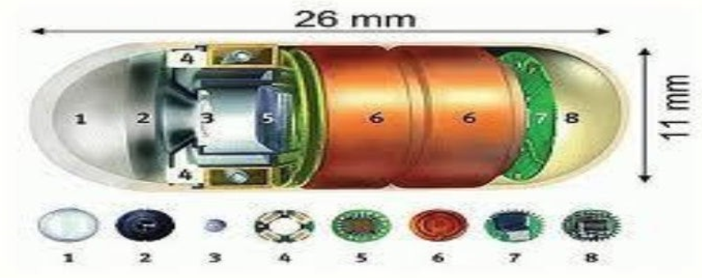8. Antenna.

Fig 4.1 internal view of the capsule

## 4.1Optical dome

It is the front part of the capsule and it is bullet shaped. Optical dome is the light receiving window of the capsule and it is a non- conductor material. It prevent the filtration of digestive fluids inside the capsule.

**4.2 Lens holder**

This accommodates the lens. Lenses are tightly fixed in the capsule to avoid dislocation of lens.

### 4.3 Lens

It is the integral component of pill camera. This lens is placed behind the Optical Dome. The light through window falls on the lens.

### 4.4 Illuminating leds

Illuminating LEDs illuminate an object. Non reflection coating id placed on the light receiving window to pr event the reflection. Light irradiated from the LED s pass through the light receiving wi nd ow.

**4.5 Cmos image sensor**

It have 140 degree field of view and detect object as small as 0.1mm. Ithave high precise.

### 4.6 Battery

Battery used in the pill camera is bullet shaped and two in number and silver oxide primary batteries are used. It is disposable and harmless material.

### 4.7 Asic transmitter

It is application specific integrated circuit and is placed behind the batteries. Two transmitting electrodes are connected to this transmitter and these electrodes are electrically isolated

### 4.8 Antenna

Parylene coated on to polyethylene or polypropylene antennas are used. Antenna received data from transmitter and then send to data recorder.

**CHAPTER 5**

**PILL CAMERA PLATFORM COMPONENTS**

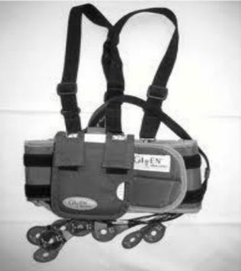In order for the images obtained and transmitted by the capsule endoscope to be useful, they must be received and recorded for study. Patients undergoing capsule endoscopy bear an antenna array consisting of leads that are connected by wires to the recording unit, worn in standard locations over the abdomen, as dictated by a template for lead placement.The antenna array is very similar in concept and practice to the multiple leads that must be affixed to the chest of patients undergoing standard lead electrocardiography. The antenna array and battery pack cam be worn under regular clothing. The recording device to which the leads are attached iS capable of recording the thousands of images transmitted by the capsule and received by the antenna array. Ambulary (non-vigorous) patient movement does not interfere with image acquisition and recording. A typical capsule endoscopy examination takes approximately 7 hours.

Fig 5.1 sensor array belt

Mainly there are 4 platform components:

1. Pill cam Capsule -SB or ESO.

2.Sensor Array Belt.

3.Data Recorder.

4.Real Time Viewer.

**CHAPTER 6**

**PILL CAMERA CAPSULE**

The disposable capsule, often referred to as a "pill-cam," is roughly the size of a large vitamin tablet, allowing it to navigate your GI tract better than a scope. Within the self-contained unit is a miniaturized video camera programmed to take between two and 18 images per second, which then ultimately get transmitted to sensor equipment. (A regular video camera shoots between 24 and 25 images per second.) Also housed within the unit is one or several tiny LED lights, a radio transmitter, and an eight-hour power source.

Several wires are attached to the abdomen like ECG leads to obtain images by radio frequency. These wires are connected to a light weight data recorder worn on a belt. Sensor arrays are used to calculate and indicate the position of capsule in the body. A patient receiver belt around his or her waist over clothing. A belt is applied around the waist and holds a recording device and a batter y pack. Sensors are incorporated within the belt. Parts of sensor array are sensor pads, data cable, battery charging, and receiver bag.

To remove the Sensor Array from your abdomen, do not pull the leads off the Sensor Arr ayl Peel off each adhesive sleeve starting with the non adhesive tab without removing the sensor from the adhesive sleeve. Place the Sensor Array with the rest of the equipment.

**CHAPTER 7**

**DATA RECORDER**

**7.1 Data recorder**

Data recorder is a small portable recording device placed in the recorder pouch, attached to the sensor belt. It has light weight (470 gm). Data recorder receives and records signals transmitted by the camera to an array of sensors placed on the patients body. It is of the size of walkman and it receives and stores 5000 to 6000 JPEG images on a 9 GB hard drive. Images takes several hours to download through several connection.

The Date Recorder stores the images of your examination. Handle the Date Recorder, Recorder Belt, Sensor Array and Battery Pack carefully. Do not expose them to shock, vibration or direct sunlight, which may result in loss of infor mation. Return all of the equipment as soon as possible.

**7.2 Real time viewer**

It is a handheld device and it enables real-time viewing. It contains rapid reader software and colour LCD monitor. It test the proper functioning before procedures and confirms location of capsule.

**CHAPTER 8**

**WORKSTATION AND RAPID SOFTWARE**

Rapid workstation per forms the function of reporting and processing of images and data. I mage data from the data recorder is downloaded to a computer equipped with software called rapid application software. I t helps to convert images in to a movie and allows the doctor to view the colour 3D images.

Once the patient has completed the endoscopy examination, the antenna array and image recording device are returned to the health care provider. The recording device is then attached to a specially modified computer workstation, and the entire examination is downloaded in to the computer, where it becomes available to the physician as a digital video. The workstation software allows the viewer to watch the video at varying rates of speed, to view it in both forward and rever se directions, and to capture and label individual frames as well as br ief video clips. I mages showing normal anatomy of pathologic findings can be closely examined in full colour.

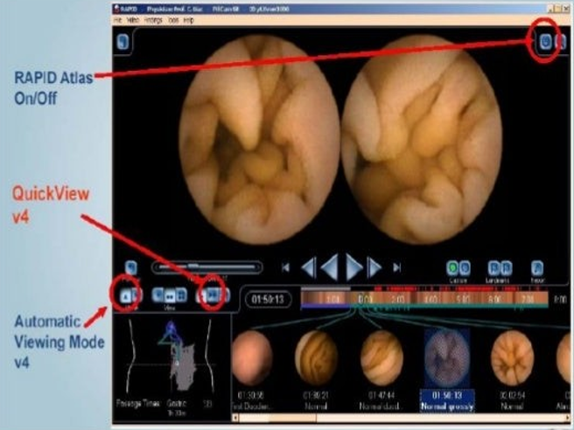A recent addition to the software package is a feature that allows some degree of localisation of the capsule within the abdomen and correlation to the video images. Another new addition to the software package automatically highlights capsule images that correlates with the existence of suspected blood or red areas.

Fig 8.1 Review and analysis using microwview and workstation

**CHAPTER 9**

**THE CAPSULE ENDOSCOPY PROCEDURES**

A typical capsule endoscopic procedures begins with the patient fasting after midnight on the day before the examination. No formal bowel preparation is required; however, surfactant (eg: simethicone) may be administered prior to the examination to enhance viewing.

After a careful medical examination the patient is fitted with the antenna array and image recorder. The recording device and its battery pack ar e worn on a special belt that allows the patient to move freely. A fully charged capsule is removed from its holder; once the indicator lights on the capsule and recorder show that data is being transmitted and received, the capsule is swallowed with a small amount of water. At this point, the patient is free to move about. Patients should avoid ingesting anything other than clear liquids for approximately two hours after capsule ingestion( although medications can be taken with water).

Patients can eat food approximately 4 hours after they swallow the capsule without inter fering with the examination. Seven to 8 hours after ingestion. The examination can be considered complete, and the patient can retum the antenna array and recording device to the physician. It should be noted that gastrointestinal motility is variable among individuals, and hyper and hypo motility states affect the free-floating capsule's transit rate through the gut. Download of the data in the recording device to the workstation takes approximately 2.5 to 3 hours. Interpretation of the study takes approximately 1 hour. Invidual frames and video clips of normal or pathologic findings can be saved and exported as electronic files for incorporation into procedure reports or patient records.

**CHAPTER 10**

**RESEARCHES**

One research suggests that , with the use of capsule endoscopy, certain gastrointestinal diseases were diagnosed from a number of patients in a hospital, such as obscure gastrointestinal bleeding(OGB) and Crone's disease, and is believed useful in investigating and guiding further management of patients suspected with the identified diseases. Another research by supports this claim, and reported that capsule endoscopy is useful for evaluation of suspected Crohn's disease, r elated enteropathy and celiac disease, and is helpful in assessment of small bowel disease of children. The third study also evaluates the potential of capsule endoscopyj and conducts a research to evaluate its safety in patients with implanted cardiac devices, who were being assessed for obscure gastrointestinal bleeding, and determine whether implanted cardiac devices had any effect on the image capture by capsule endoscopy.Thus, study concludes that capsule endoscopy was not associated with any adverse cardiac events, and implanted cardiac devices do not appear to interfere with video capsule imaging. To put it simply, the three researches conducted, emphasize that the use of capsule endoscopy is safe, has no side effects, effective, and is efficient in the careful diagnosis and treatment of the patients.

All of the three research studies were able to effectively convey their message and aim, and give importance to the value and efficiency of using the capsule endoscope as a way of evaluating the existing gastrointestinal diseases of patients. The researches were done by letting the participants swallow the capsule endoscope for the physicians to examine and assess the conditions of their gastrointestinal tract by the image captured by the capsule endoscope. This process does not only help to detect the severity of the existing gastrointestinal disease but also determine its effective to the presence of implanted cardiac devices.

**CHAPTER 11**

**ADVANTAGES AND DISADVANTAGES**

**11.1 Advantages**

* Painless, no side effects.
* Miniature size.
* Accurate, precise (view of 150 degree) .
* High quality images.
* Harmless material.
* Simple procedure.
* High sensitivity and specificity .
* Avoids risk in sedation.
* Efficient than X-ray CT-scan, normal endoscopy.
* Gastrointestinal obstructions prevent the free flow of capsule.
* Patients with pacemakers, pregnant women face difficulties.

**11.2 Disadvantages**

* It is very expensive and not reusable.
* Capsule endoscopy does not replace standard diagnostic endoscopy.
* It is not a replacement for any existing Gl imaging technique, generally performed after a standard endoscopy and colocoscopy.
* It cannot be controlled once it has been ingested, cannot be stopped or steered to collect close-up details.
* It cannot be used to take biopsies, apply therapy or mark abnormalities for surgery.

**CHAPTER 12**

**APPLICATIONS**

* It is used to detect ulcers
* Biggest impact in the medical industry.
* Nano robots perform delicate surgeries.
* Pill cam ESO can detect esophageal diseases, gastrointestinal reflex diseases, barreffs esophagus.
* It is used to diagnose Malabsorption
* Pill cam SB can detect Crohnis disease, small bowel tumours, small bowel injury, celiac disease, ulcerative colitis etc.

**CHAPTER 13**

**FUTURE SCOPES**

It seems likely that capsule endoscopy will become increasingly effective in diagnostic gastrointestinal endoscopy. This will be attractive to patients especially for cancer or varices detection because capsule endoscopy is painless and is likely to have a higher take up rate compared to conventional colonoscopy and gastroscopy. Double imager capsules with increased frame rates have been used to image the esophagus for Barrett's and esophageal varices. The image quality is not bad but needs to be improved if it is to become a realistic substitute for flexible upper and lower gastrointestinal endoscopy. An increase in the framerate, angle of view, depth of field, image numbers, duration of the procedure and improvements in illumination seem likely.

Colonic, esophageal and gastric capsules will improve in quality, eroding the supremacy of flexible endoscopy, and become embedded into screening programs. Therapeutic capsules will emerge with brushing, cytology, fluid aspiration, biopsy and drug deliver y capabilities.Electrocautery may also become possible. Diagnostic capsules will integrate physiological measurements with imaging and optical biopsy, and immunologic cancer recognition. Remote control movement will improve with the use of magnets and/or electro stimulation and perhaps electromechanical methods. External wireless commands will influence capsule diagnosis and therapy and will increasingly entail the use of real-time imaging. However, it should be noted that speculations about the future of technology in any detail are almost always wrong.

The development of the capsule endoscopy was made possible by miniaturization of digital chip camera technology, especially CMOS chip technology. The continued reduction in sizej increases in pixel numbers and improvements in imaging with the two rival technologies-CCD and CMOS is likely to change the nature of endoscopy. The current differences ar e becoming blurred and hybrids are emerging. The main pr essure is to reduce the component size, which will release space that could be used for other capsule functions such as biopsy, coagulation or therapy. New engineering methods for constructing tiny moving parts, miniature actuators and even motors into capsule endoscopes are being developed

Although semi- conductor lasers that are small enough to swallow are available, the nature of lasers which have typical inefficiencies Of 100-1000 per cent makes the idea Of a remote laser in a capsule capable of stopping bleeding or cutting out a tumour seems to be something of a pipe dream at present, because Of power requirements

The construction of an electrosurgical generator small enough to swallow and powered by small batteries is conceivable but currently difficult because of the limitations imposed by the internal resistance of the batteries. It may be possible to store power in small capacitors for endosurgical use, and the size to capacity ratio of some capacitor s has recently been reduced by the use of tantalum. Small motors are currently available to move components such as biopsy devices but need radio- controlled activators. One limitation to therapeutic capsule endoscopy is the low mass of the capsule endoscope (3.7 g). A force exerted on tissue for example by biopsy forceps may push the capsule away from the tissue. Opening small biopsy förceps to grasp tissue and pull it free will require different solutions to those used at flexible endoscopy-the push force exerted during conventional biopsy is typically about 100 g and the force to pull tissue free is about 400 g.

Future diagnostic developments are likely to include capsule gastroscopy, attachment to the gut wall, ultrasound imaging, biopsy and cytology, propulsion methods and therapy including tissue coagulation. Narrow band imaging and immunologically or chemically targeted optical recognition of malignancy are currently being explored by two different groups supported by the European Union as FP6 projects: -the VECTOR and NEMO projects. These acronyms stand for: VECTOR Versatile Endoscopic Capsule for gastrointestinal Tumour Recognition and therapy and NEMO Nano-based capsule-Endoscopy with Molecular Imaging and Optical biopsy.

The reason because of doctors rely more on camera pill than other types of endoscope is because the former has the ability of taking pictures of small intestine which is not possible from the other types of tests.

**CHAPTER 14**

**CONCLUSION**

Wireless capsule endoscopy represents a significant technical breakthrough for the investigation of the small bowel, especially in light of the shortcomings of other available techniques to image this regiom Capsule endoscopy has the potential for use in a wide range of patients with a variety of illnesses. At present, capsule endoscopy seems best suited to patients with gastrointestinal bleeding of unclear etiology who have had non-diagnostic traditional testing and whom the distal small bowel(beyond reach of a push enetroscope) needs to be visualised.

The ability of the capsule to detect small lesions that could cause recurrent bleeding(eg. tumours, ulcers) seems ideally suited for this particular role. Although a wide variety of indications for capsule endoscopy are being investigated, other uses for the device should be considered experimental at this time and should be performed in the context of clinical trials.

Care must be taken in patient selection, and the images obtained must be interpreted approximately and not over read that is, not all abnormal findings encountered are the source of patientis problem. Still, in the proper context, capsule endoscopy can provide valuable information and assist in the management of patients with difficult —to- diagnose small bowel disease. In this study capsule endoscopy was superior to push enteroscopy in the diagnosis of recurrent bleeding in patients who had a negative gastroscopy and colonoscopy. It was safe and well tolerated

Wireless capsule endoscopy represents a significant technical breakthrough for the investigation of the small bowel, especially in light of the shortcomings of other available techniques to image this region.

The capsule endoscopy seems best suited to patients with gastrointestinal bleeding of unclear etiOlogy who have had nondiagnostic traditional testing and in whom the distal small bowel(beyond reach of a push enteroscope) needs to be visualized.

**CHAPTER 15**

**REFERENCES**

1. news.bbc.co.uk.lhomepage on the internet] . "Spider pill used for scans. updated on oct 11th 2009. Available from: http://news.bbc.co.uk/2/hi/science/nature/ 8301232.stm.

2. sciencedailylhomepage on the intemetl. Magnet Controlled Camera In The Body. Upated on June 9th 2008. Available from: [http://www.sciencedaily.com/rele ases12008/06/080603105634.htm](http://www.sciencedaily.com/rele%20ases12008/06/080603105634.htm).

3. Mylonaki M, et al. "Wireless capsule endoscopy a comparison with push enteroscopy in patients with gastroscopy and colonoscopy negative gastrointestinal bleeding". Gut,

4. "Capsule endoscopy turning up undiagnosed cases of Crohn's disease". Physorg.com

Pink Tentacle. "Sayaka: Next-generation capsule endoscope .

6. Chong A, Taylor A, Miller A, Desmond P. Initial experience with capsule endoscopy at a mgior referral hospital. MJA 2003;178 (I l): 537-40. Available [online] at URL:http://www.mja.com.au/public/issues/178